Concours Registration:
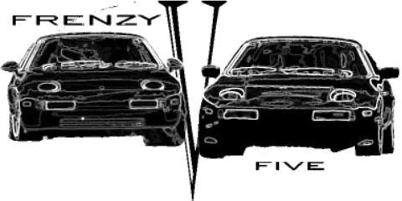
“Finale Concours Featuring the 928”

Event Date: October 14, 2001
Location: Curry’s Auto Service
1510 Moran Road
Sterling, VA 20166

Entrant: ____________________________

Porsche Year______ Model_____________

Address: _____________________________
_____________________________________
Phone: (D)___________(E)______________
EMAIL:______________________________
This is a FREE Event!!
Class: Concours O “Low Key” Interior and Exterior Judging Only
Wash n Shine O “ Display Only”

Is This Your First Concours? ____________

Paul Faupel, Jr., 8322 Glenmar Rd., Ellicott City, MD. 21043

Contact @ 410-461-3480 or concours@pcapotomac.org

This Concours is in conjunction with Frenzy V and is open to all Porsche cars

Proud Sponsor


