Porsche 944 Dash Removal and Installation

Scott Levy

Introduction

Remove the steering wheel.
- Remove the center console.
- Remove the sun visors.
- Remove A-pillar trim.
- Remove instrument cluster trim.
- Remove climate control trim and climate control.
- Remove steering wheel trim.
- Remove instrument cluster
- Remove glove box trim (piece with clock, hazard switch, lock, etc.).
- Remove glove box.
- Remove dash.
- Install replacement dash.
- Install instrument cluster.
- Install glove box trim.
- Install steering wheel trim.
- Install glove box.
- Install climate control and trim.
- Install instrument cluster trim.
- Install A-pillar trim.
- Install the center console.
- Install the steering wheel.
- Final inspection.

I. Introduction

Replacing the dash on a late model, 85.5 and newer Porsche 944, is not a difficult task. It is very time consuming and meticulous. Patience is necessary. An extra pair of hands is not required, but will make some parts of the job easier. I’m assuming you have a standard shift, and no airbags. I have not seen the underside of a dash with airbags and I’m not sure that I want to. Read through this whole guide before taking on the job. You’ll have a better idea to how things fit together. It’s a big 3D puzzle. Also, I take no responsibility for damage you incur while using this guide. This is a guide only. This is not meant to replace service manuals or professional assistance. In other words, if you don’t think this is good enough for you, don’t use it and seek out a professional. I have tried to be as complete as possible, but I may have left something out.

I recommend having a system to safely store the screws that come off the dash. Porsche uses different sizes, many looking very similar. A couple of ideas, use sandwich bags to store the screws for the trim piece associated with it, or use small dixie cups. Make sure to label the bag/cup with what trim piece it goes to. A source for extra screws is a plus. Many of our dashes don’t have all their original hardware.

You may have to transfer some parts from your dash to the new dash. Side vents, glove box door and lock, center console mounting brackets, etc…..

I would recommend having a pad and pencil ready to make notes as you go along. When you are reinstalling the dash, possibly 4-5 days later, you will need some sort of memory refresher. I used a Polaroid camera to take pictures of how things fit together and what wiring harness went where.

The car will give you problems while doing this project. Expect it. When doing this, I couldn’t get the top screw out from my passenger side A-pillar trim. I ended up having to drill the head off it to get the trim out. I was then left with a stub of a screw sticking out. I cut it off with a dremel, drilled a new hole right next to and used a new screw. It’s not the optimal way to repair this, but it worked and is a good example of unexpected trouble. Also, you’ll probably break something. Do this job over a few days to give yourself time to find replacement parts. You’ll be much happier knowing you have a good piece in the dash instead of something you may have to glue to get working right.

Disconnect the negative battery cable. I didn’t do this and wound up replacing just about every dash light bulb and a number of fuses.

A note on disconnecting the wiring harness from the dash switches. This is not really easy to do. I’ve found it’s better to be very patient and use a small blade to pry with than to squeeze, yank, pull, or use brute force. Using brute force, you’ll either break the clips that hold the harness to the switch or the clips that hold the switch to the trim. Remember, most of our cars are at least 10 years old and the plastic gets brittle.

Let’s get started………

II. Remove the Steering Wheel

- Remove the horn pad. This is done by pulling on the pad, very hard. The pad may seem like it won’t come off, keep pulling.
- Disconnect the horn ground wire from the back of the pad.
- Using a 15/16” or a 28mm socket remove the retaining nut from the steering wheel. There will also be a washer behind the nut, remove it.
- Make sure the wheel is straight. Remove the wheel by pulling it off the yoke.

III. Remove the Center Console

- Remove the ashtray.
- Remove the radio. (Actually, you may not have to. You’ll see later.)
- In the cassette holder, under the lid, at the rear, are two screws. Remove them.
- At the front of the cassette holder, where the ashtray sits, are two small screws. Remove them. You should now be able to remove the cassette holder.
- At the rear of the shifter trim are two small screws. Remove them.
- Remove the pocket that is under the radio. It just pulls out.
- With the shift boot still attached, you should be able to lift this trim up from the console. You will have to remove the boot from the trim. The boot is attached to the trim with a plastic ring that clips to the bottom of the trim. Carefully free the clips and the boot will come free. You should now be able to slip the trim over the shifter.
- Disconnect the wiring from the switches. The wiring harness should be numbered. Starting at 1 on the left. They will be reconnected in this order.
- Remove the center console retaining screws. One each on either side, up towards the front.
- Now you should be able to remove the center console. Slide it to the rear of the car. Lift it over the shifter. If you left the radio in, be sure to disconnect it first.
- There are 2 brackets attached to the dash used to hold the center console. One for each side of the center console. Remove these brackets from the dash and set them with the center console. You may need them for the new dash. Yes, there is a left and a right to these brackets. Note their orientation!

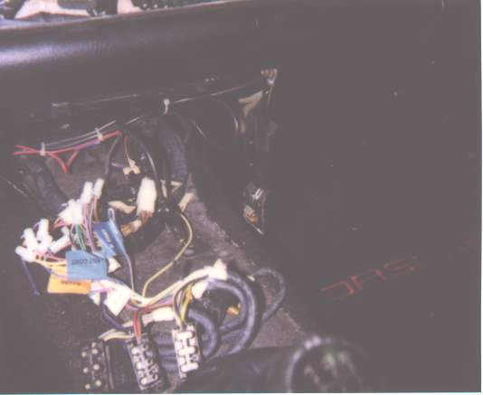
This is one of the brackets used to attach the center console to the dash. There is another one on the other side.

Here you see the wiring harness for the center console switches. These are numbered starting at 1 on the left most connector.

IV. Remove the Sun Visors

- Note the orientation of the pivot end of the visor.
- Remove the 3 screws holding the pivot end.
- Remove the 2 screws holding the visor clip.

The visor and clip should be free now. Don’t lose the washers in the clip. It is necessary to do this to facilitate the removal of the A-pillar trim in the next section. Don’t pull the header down too far, just enough to expose the end of the A-pillar trim.

V. Remove the A-pillar Trim

The A-pillars have 3 screws holding them into place. Black plastic covers hide the screws.

- Remove the screw covers.
- Remove the lower 2 screws.
- The uppermost screw may not be visible. It is put into the trim directly vertical. If you fish around in the hole with your screwdriver, pointing straight up at the sky, you should find it. Remove this screw.
- Loosen the door edge cover by pulling it off. (Rubbery trim going around the door opening.)
- You can now remove the trim. Slight wiggling may be required.

VI. Remove Instrument Cluster Trim

The instrument cluster trim is the piece that frames the instrument cluster. This also includes the center vents and the trip odometer reset button.

- Remove the 3 screws from the center vents. Be careful not to drop them into the ducts.
- Remove the 3 screws from the top of the trim above the instruments. Use a stubby screwdriver. These screws go straight up into the dash.
- There are 2 screws in the bottom. One on either side of the steering column. They go in from the bottom into the bottom of the trim. Remove these screws.
- You can now remove the trim. Some wiggling may be necessary. Be careful not to scratch the instrument cluster lens. (I did!)

VII. Remove Climate Control Trim and Control Unit

If you look at the control unit trim, you’ll notice there are no screws. This piece is snapped on over the control unit. It covers screws behind it on each side of the control unit.

- Gently pull off the sliders.
- From the top of the unit, carefully pry the trim until it comes off. A small knife blade should work very well for this. There is no need to remove the knobs.
- Once the trim is off, you’ll see 2 screws on each side of the control unit. Remove these screws.
- You can now, gently, pull out the control unit from the dash. The clear plastic tabs for the screws are easily broken. BE CAREFUL! If you break a tab, you have to buy a whole control unit.
- Remove the wiring harness from the back of the control unit. Note the orientation of the harness. It’s keyed, do it anyway.

The reason we start here for the dash trim is that the screws also hold the trim on each side of the control unit. If you start at one end or the other, you risk breaking the tabs off other trim pieces.

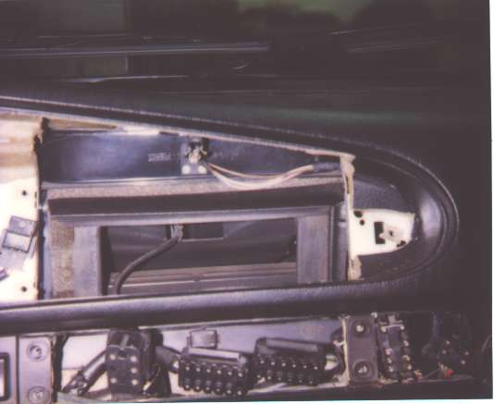
This is a picture of the climate control opening. Notice the screw location on either side of the opening. These screws hold the climate control and the trim on either side of it.
Directly above is the climate control wiring harness.

VIII. Remove Steering Wheel Trim

- Remove turn signal assembly trim by removing 3 small screws. Trim pulls off over steering column.
- Remove rubber surround from ignition key assembly. Slide a knife blade carefully underneath it and pull. It may be somewhat tough. Be careful not to slice the rubber or tear it. There is a metal ring at the back of this piece. It should come off with the rubber.
- Remove the screws from this trim piece. There should be 1 in the bottom and 1 next to the steering column, may be slightly hidden.
- You should now be able to remove the piece. Disconnect the wiring harness and note orientation.
- Remove the headlight switch knob. Do this by pulling and wiggling.
- There is a cover hiding 2 screws just to the left of the fog light switch. Remove the cover and the screws.
- On the side of the dash, there is a cover with 1 screw in it. Remove the screw and the cover. This will expose 2 screws in the end of the trim.
- Remove the 2 screws holding the upper vent. Remove the upper vent.
- Remove the 2 screws in the trim and center the vent shutoff lever.
- Remove remaining screws in the trim piece. One just left of the steering column and 1 on the bottom.
- Now you have to remove the headlight switch. Remove large nut from the switch. Switch will slide out the rear of the trim piece.
- You should now be able to remove this piece. Disconnect wiring harness from fog light switch.
- Now you have to remove the turn signal/wiper control assembly. This is all one unit and is mounted to the steering column by a collar and one bolt.
- Note the position of this assembly on the steering column.
- Loosen the collar bolt. I think it a 10mm.
- Slide the assembly off the steering column disconnecting the wiring harness as you go.

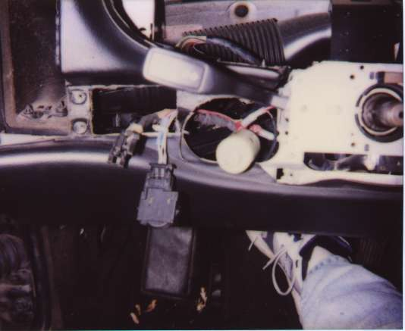
Here you can see the left side trim removed. The turn signal assembly is still on the steering column.
Fog light wiring
Headlight switch
Panel dimmer

IX. Remove the Instrument Cluster

Before we get into the actual removal of this, let me talk about the wiring harness connectors used here. The connector is black plastic and there are 3 of them. They all look the same, I’m not sure if they are keyed or not. The connector has 2 arms, one on each end. The purpose of the arms is to lock the connector into place. The arms lock the connector by hooking to the instrument cluster. Once hooked, the arm rotates and locks itself down. The arm locking mechanism itself works kinda like a battery door on a remoter control. You'll see what I mean when you get in there. You push down, slightly, and pull the arm out of it’s locked state. Ok, now that I’ve totally confused you. Let’s remove the instrument cluster.

- Remove the 4 screws holding the instrument cluster into place.
- Carefully remove the cluster from the dash.
- Disconnect the wiring harness and note orientation.

While this is out, it’s a good time to replace any burnt bulbs. Also, while you’re in this area, note the orientation of the trip odometer reset switch. It’s not really attached to the dash. It’s just set into 2 locating holes. You’ll want it to be exactly where it is when you put things back together.

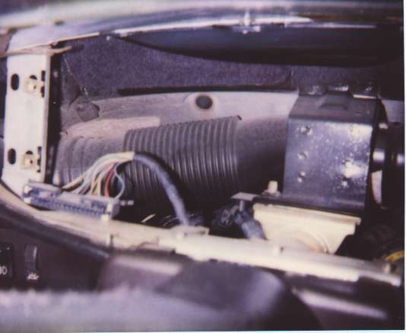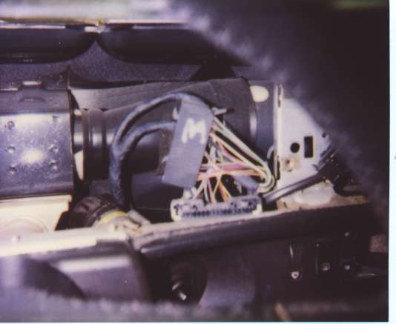

Here you can see the wiring harness for the instrument cluster, indicated by the yellow arrows. The red arrows show 3 of 4 mounting points for the instrument cluster. In the background, you can see the duct running to the side vent on the driver side (light blue arrows). The green arrows indicate one of the locking arms for the connector and it’s hook on the other end.

X. Remove Glove Box Trim

Notice the little circular vent next to the cigarette lighter. This is the interior temperature sensor for the climate control system. Attached to the backside of this vent is a hose that runs to just about the firewall under the dash. Be careful not to pull the trim out too far once you have all the screws loosed. You want to disconnect the hose at the trim piece, not at the other end by the firewall. Here we go…..

- Remove the circular vent by turning it counter clockwise. It’s kinda like the piece that holds the ball into the bottom of a computer mouse.
- Inside at the bottom of the vent you’ll see a small screw and washer. Remove them.
- On the end of the dash, you’ll find the end cover. Remove the screw that holds it and the cover. This will expose the 2 end screws for the trim piece.
- Remove the 2 screws.
- Just next to the vents, you’ll find a cover hiding 2 more screws. Remove this cover and the 2 screws under it.
- The hazard switch, clock, cigarette lighter are attached directly to this piece. As always, be careful removing wiring harnesses.

While you’re here, might be a good time to replace that broken clock.

XI. Remove the Glove Box

The glove box is held in by a number of screws in the front on each side, 2 into the top by the light and a big metal clamp at the back. This isn’t hard.

- Remove all screws on the front, sides, top of the glove box.
- Crawl under the dash. Disconnect the air hose going to the vent in the glove box. (Yes, the glove box has air conditioning.)
- Carefully pull the box out the front opening. You’ll have to bend the top down slightly to clear the light assembly. Disconnect the wiring just after you get the light assembly clear.

The glove box door is a part of the dash as well as the lock. These items can be transferred to the new dash if the replacement doesn’t have them.

XII. Remove the Dash

The moment you’ve been waiting for! Be sure all wiring is clear. You may want to take a deep breath at this point. It isn’t a pretty sight when the dash is out.

- Remove the upper mounting screws. One in each A-pillar.
- Remove the lower mounting screws. One in each side of the dash, down towards the bottom.
- Gently, carefully, pull the dash straight out. Ductwork from the climate control system to the side vents will have to be removed from the dash. I don’t recommend removing the ducts from the system. Leave them attached at the system end. Another set of hands comes in handy here in case you get hung up on something.
- Have a beer, you’re half way done with this project!

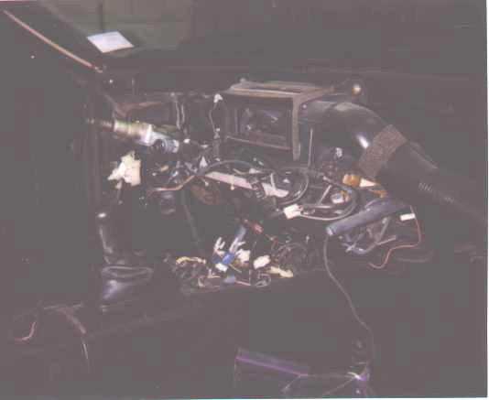
Inside temperature sensor hose
Side vent duct

XIII. Install Replacement Dash

Well, now you’ve done it! You have your dash out and you’re probably scratching your head wondering how you’ll ever get things back together. Believe me, things go much quicker in reverse.

You need to look over your firewall at this point. If you were having any climate control problems that aren’t related to the control unit itself (leaking heater core, mechanical issues with the system, etc.), now is the time to take care of things. The top of the firewall is covered in black felt. Look to be sure all of it is in place and in good shape. This felt prevents the metal frame of the dash from rubbing on the metal firewall and making a lot of noise. Look over your wiring harnesses for any damaged, worn, torn, wiring. If all looks good, let’s put in a new dash.

Looking at the firewall, you’ll see a small ledge covered in felt. This is where the dash rests on top. Have the top screws ready and an extra pair of hands. I’ve found you’ll want someone to hold the dash as you manipulate it into place. If you get the dash in and it doesn’t seem to fit quite right, it’s probably caught on something. The lower mounting brackets are easy to catch.

- Install upper side vents into new dash.
- Set new dash into car letting it rest on firewall ledge.
- Install screws in upper mount. Hand tighten only at this point.
- Reconnect climate control ducts to side vents.
- If dash looks in place, hold against firewall while installing lower mounting screws.
- Be sure dash is in it’s final resting place while tightening all screws.

XIV. Install Instrument Cluster

- Install instrument cluster into it’s dash opening.
- Connect wiring harness. Be sure to lock down the connector arms.
- Install and tighten screws.
- Now is a good time to be sure trip odometer reset switch is in place.

Instrument cluster mounting screws

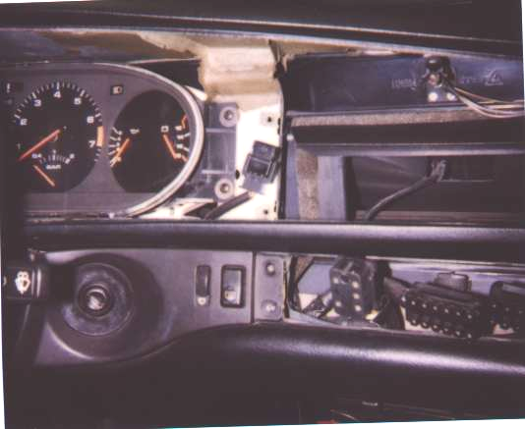
Trip Odometer Reset switch

XV. Install Glove Box Trim

- Place trim piece where you connect wiring harness and temperature sensor hose.
- Install into dash.
- Install all screws and tighten except for 2 by climate control.
- Install dash side cover and tighten.

XVI. Install Steering Wheel Trim

- Install turn signal/wiper switch assembly by sliding it over the steering column. Connect wiring harness as you go.
- Be sure position of this assembly is where you want it and tighten the collar bolt.
- Install left side trim first. Mount headlight switch and tighten nut. Connect wiring for fog light switch.
- Install screws and tighten. The bottom screw also goes into right side trim.
- Install headlight switch knob. Notice it’s keyed.
- Install right side trim. Connect wiring harness.
- Install all screws except 2 by climate control. They’ll go in with the climate control.
- Install rubber surround over ignition. Press it onto ignition as far as you can.
- Install turn signal/wiper assembly trim and tighten down with the 3 small screws.
- Install dash side cover and tighten.

This is a shot of the steering column without the trim work on either side or the turn signal assembly. Notice the funny looking connectors.

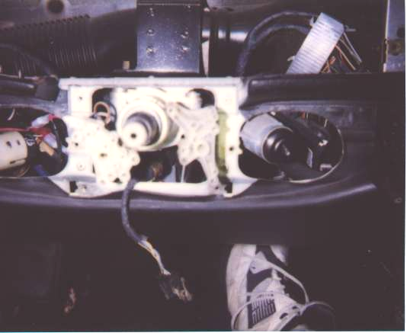
Headlight switch

Turn signal assembly connectors
Ignition switch

Cruise control
My foot

XVII. Install Glove Box

- Slide the glove box into it’s opening in the dash. An extra helper is good here because it’s tough to get the box into the metal clamp on the firewall while adjusting it to clear the light assembly. Don’t forget to connect the wiring for the light before putting it in.
- Once the box is in right, connect the hose for the A/C vent.
- Install all the screws and tighten.

XVIII. Install Climate Control Unit and Trim

- Connect wiring harness and slide unit into dash.
- Install all 4 screws and tighten.
- Install trim by snapping it on over control unit.
- Install sliders.

XIX. Install Instrument Cluster Trim

- Slide, wiggle trim piece into place. Be sure trip odometer reset switch is in place first.
- There is a light bulb at the top of the dash for the defroster slider that is between the center vents. Before you screw in this piece, test this light. I found after I put this piece in, I had light leaking into the center vents and elected to remove this light bulb. The purpose of this bulb is to backlight the slider.
- If everything is ok, install all the screws. 3 by the center vents. 3 into the top of the dash. 2 on either side of the steering column.

XX. Install A-pillar Trim

- Place trim piece into position.
- Install and tighten screws.
- Tuck vinyl under door edge cover and reinstall.
- Repeat for other side.
- Reset header panel up against top of car.
- Reinstall sun visors and clips. Yes, there is a left and a right.

XXI. Install the Center Console

- Remember the 2 brackets we took off the old dash in section III? Time to put them on the replacement dash. There is a left and right.
- Slide the center console into place.
- Install the screws holding it on each side.
- Install and reconnect the radio if you removed it in section III.
- Install and the trim that goes around the radio/shifter. Reconnect the wiring harness.
- Install the shift boot and it’s hold down ring.
- Install the screws at the rear of this piece that hold it into place and tighten.
- Install the cassette holder and tighten it’s screws.
- Replace the ashtray.

XXII. Install the Steering Wheel

- Install steering wheel straight onto column yoke.
- Install washer, nut and tighten.
- Unlock column with key and test wheel to be sure turn signals cancel as they should.
- Connect horn ground wire and install horn pad. Test horn. If horn doesn’t work, check to be sure the wheel is making connection with the copper strips on turn signal assembly. Adjust assembly as needed. There should be about 1/8” space between the wheel and this assembly. If the wheel is too close, it will make a grinding noise when turned.

XXIII. Final Inspection

At this point, all should be back together and looking good. Reconnect the battery cable. Car should start. All dash lights should be functional. All switches and accessories should work.

If something doesn’t, check the wiring harness for that item and make sure it’s connected correctly. Check fuses. If all else fails, take that section apart and have a look.

If all went back together ok, any rattles or squeaks should go away after the replacement dash settles into it’s new home. Mine squeaked for about a week after the job. Now it’s solid as a rock, not a rattle to be heard.

This is a great job for the mildly mechanically inclined. It provides great satisfaction and really teaches you how to be patient when the car throws you a curve.

Go out for a drive and appreciate your great work!

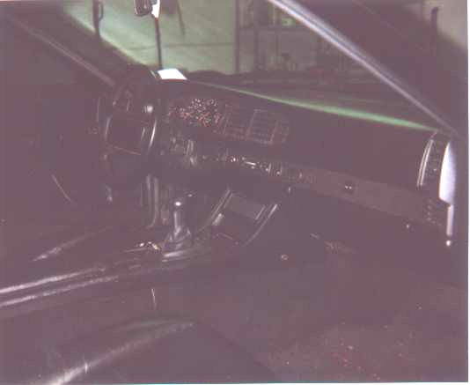

- 944 dashboard lighting improvement (85 1/2 - 91 dash style)

- I posted a rennlist message about this back in 1999 and got lots of inquiries, so here is the procedure. Hopefully it makes sense and will improve your dash lighting. This only applies to the dash style shown below.
- 1. Disconnect the negative battery terminal.
2. Remove steering wheel cover by pulling gently on it, then detach horn wire. Next, use deep socket to remove the nut holding the steering wheel on. Mark steering wheel position and pull it straight off.
3. Remove the plastic oval dash cover by removing a total of 8 screws. It pulls out directly. You should now have access to the 4 screws retaining the instrument cluster.
4. Remove these 4 screws and pull the cluster out. Next, detach the 3 electrical connection brackets behind the cluster. The cluster will now be free to remove from the car.
5. Identify the 3 light tunnels underneath the cluster. They originally had a silver reflective coating painted on. This coating will probably be deteriorated and worn off. Do NOT remove the light tunnels from the cluster - leave them in place. Use some method to scrape off this reflective coating so that the tunnels are completely clear. I used sandpaper, but this will scuff them too much. Paint thinner may be effective, but I can't promise results because I did not use this.
6. Next, use double sided scotch tape to secure aluminum foil to the 3 light tunnels, shiny side facing down (toward the tape). This shiny side will be used to refract the light from the bulbs through the tunnel to the dash. Make sure the foil completely covers the tunnels.
7. Replace the dash light bulbs with 3 watt bulbs (available at most auto parts stores). DO NOT use light bulbs brighter than 3 watts - they will draw too much current, overheat, and melt the plastic light bulb retaining sockets. This is BAD!
8. When you have the light bulbs replaced and the light tunnels resurfaced, install everything back the way it came and try it out. As Haynes says, "installation is the reverse of removal." If you have no light at all, check your connections and try again.
9. Problems? E-mail me with questions.

